Huge Plant Sale
and Bake Sale!
Saturday, April 9th
10 am to 4 pm
*** Rain or Shine *** Free Admission ***

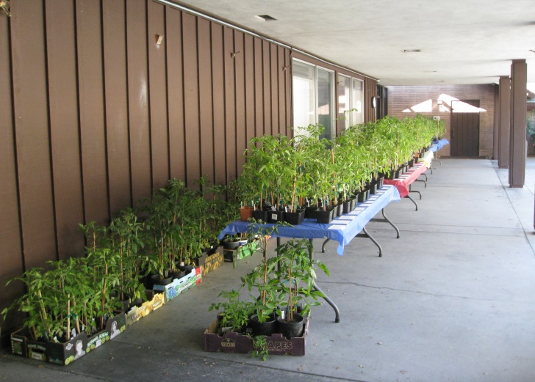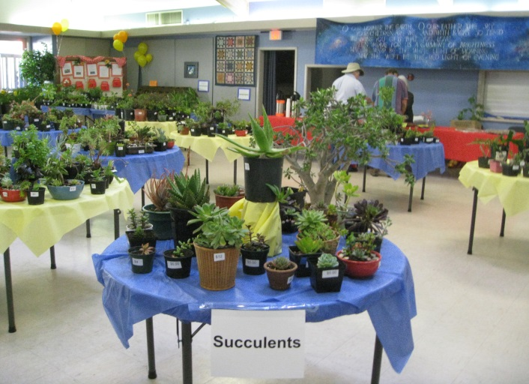

Montclair Presbyterian Church
5701 Thornhill Drive, Oakland 94611

- Forty-nine varieties of HEIRLOOM TOMATOES!!!
- Drought-resistant plants
- Lots of IRIS, SUCCULENTS and CACTI
- Orchids and Bromeliads
- HERBS and VEGETABLES
- California Natives
- Perennial flowers grown from seed last year
- SEEDS, Bulbs, Pots and Supplies

Church 510-339-1131 Chairperson Amy Bess 510-339-2477

